**Test Document for Rights of purchase receipt correction**

Maintain table tdisg0115m000 – Users for Purchase Receipts Correction

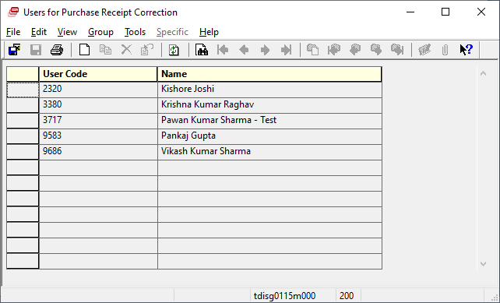

My Id is not enter now testing for Purchase Receipts Correction:

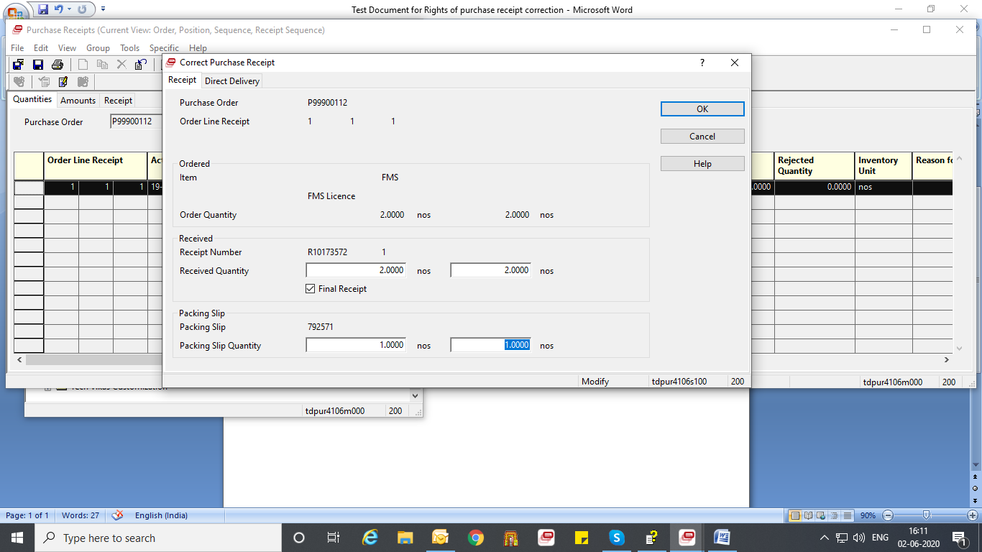

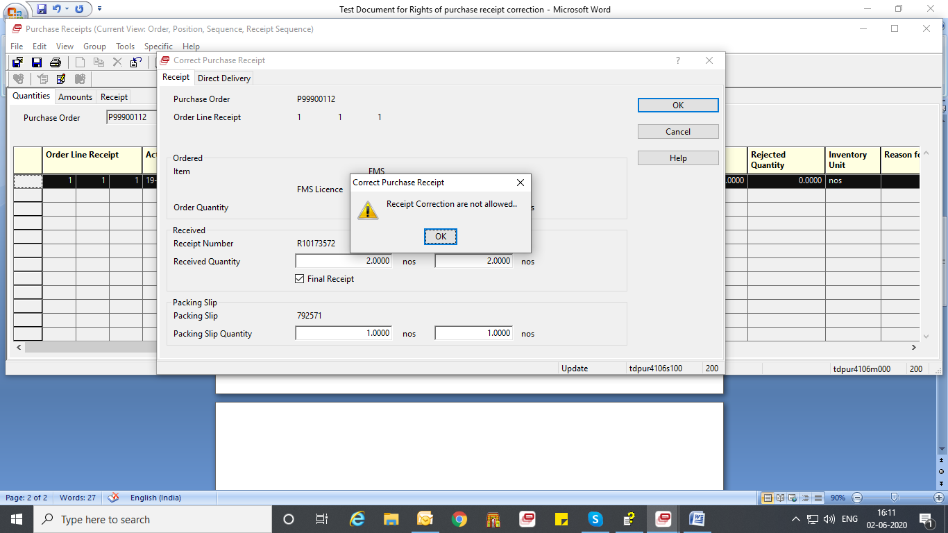

Now enter ID 3776

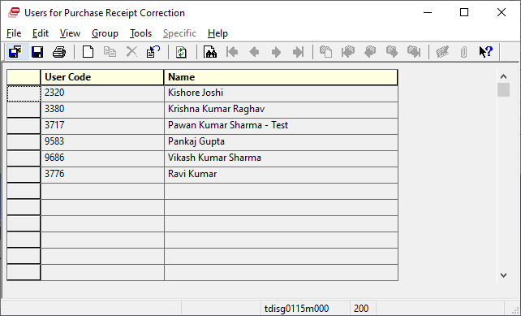

Now test in Purchase Receipts

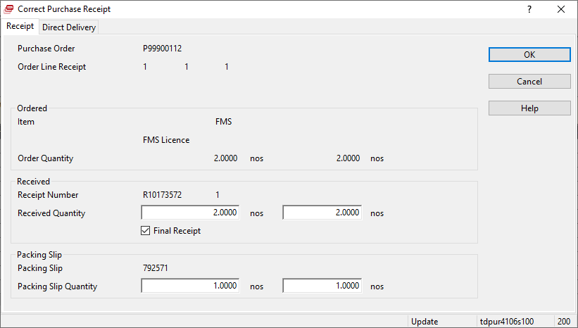

Processed.